Reflective Journal

Student name: **Joey Tatú - 15015556**

Programme: **BSc (Hons) in Computing – Software Development**

Month: **October 2019 (Week 3 – 6)**

# My Achievements

## Week 3 (30/09):

I was sick this week, so I didn’t get anything done.

Week 4:  
Monday:

I worked on the Project Proposal today. I took parts of it from my Project Proposal last year. I emailed Eamon and Paul to ask them if references were needed. I assume they are.

I also worked on the Lab from Week 3 in Data Application Development. Tomorrow and Thursday, I want to do research on the technologies for websites dealing with appointments. I think Java and SQL will be sufficient, but if I can find something better, that world be good too.

### Tuesday, Wednesday and Thursday:

I worked on the Data Application Development (DAD) labs, as well as doing tutorials on Python. I felt Python isn’t fully explored in the DAD module, so I decided to get a head start while I could.

### Friday:

Friday was a bad day for me, mental health wise and I didn’t do anything. I try to keep my weekends free.

## Week 5 (07/10):

### Monday:

**09:10 –** Talked with my supervisor, Paul Stynes about my project. He reviewed my video again and discussed with me about the idea. He said that the idea is similar to a bricks and mortar store where everything is done manually, but he suggested looking at Google Scholar and looking for automation and delving deeper into the Artificial Intelligence part of the project.

**09:30 –** Paul did a seminar about Software Requirements.

1. Use Cases. Actor -> Use Case
2. NO! Use Case to Actor
3. Use Cases to Use Cases
4. 4 to 6 Use Cases.
5. Functional Decomposition is Actor -> Use Case -> Actor. (If it gets big – NO)

**10:00 –** I have been looking at the link Paul provided and I am understanding the general concept. What I have provided is a brick and mortar scenario where the tattooist (etc) and the client are doing things manually. And I want to automate this process. But the question remains; “how do I do that?” Seemingly with my project idea last year and this year, I seem to go for something complicated and not really discussed in a scholar environment. It’s a little bit frustrating.

From: <https://pdfs.semanticscholar.org/65a6/7db9ba8992b27bfda0a134afa1397e2c8af7.pdf> :

“In-store Technologies in the Retail Servicescape”.

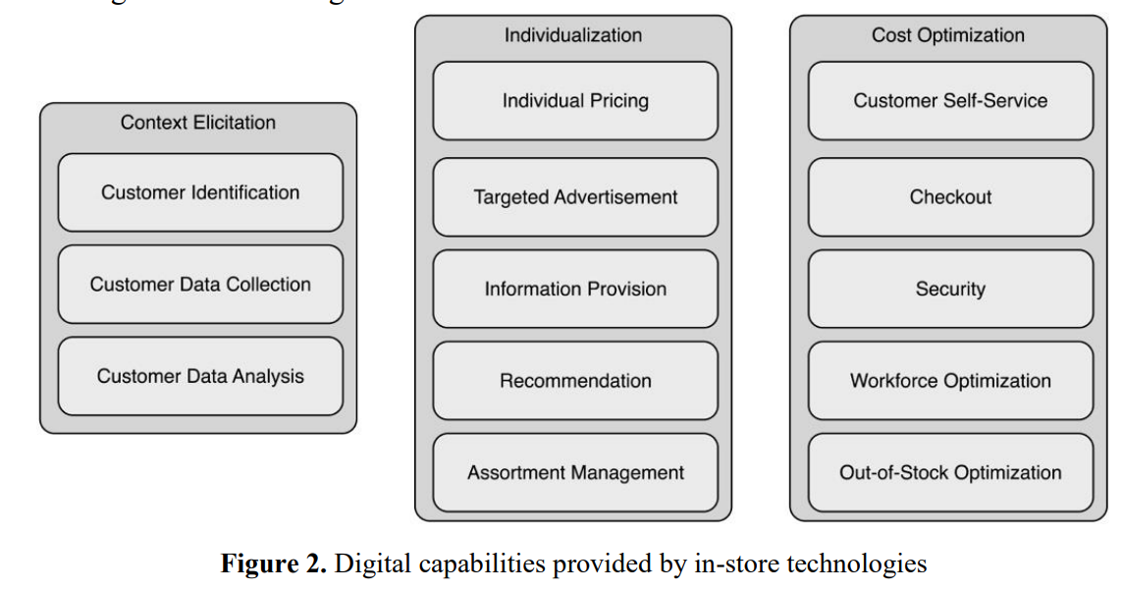

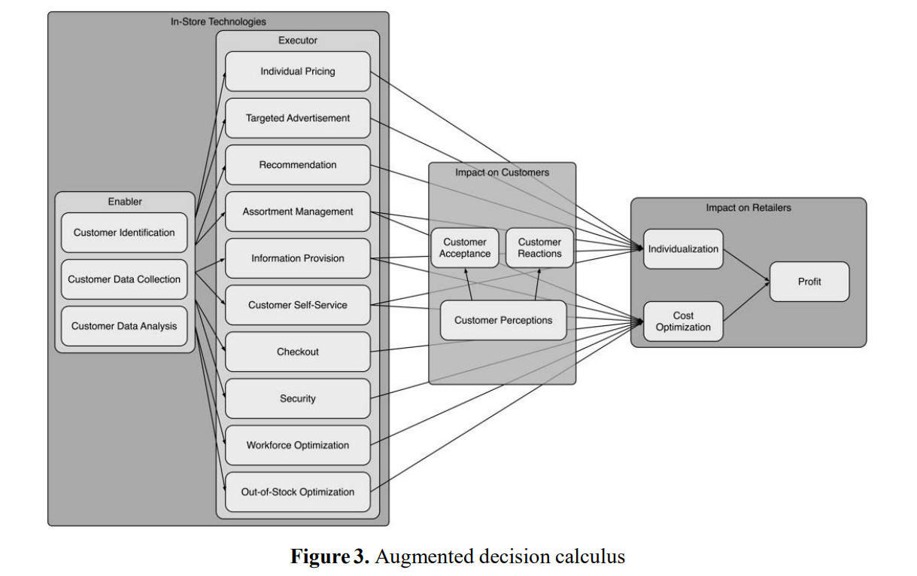

I was thinking of how I could do something similar but change it for body modification’s artists and clients. It makes sense to me.

### Tuesday

I went to my Data Application Development (DAD) class and worked on the sample retrieving data from Twitter (ETL Airlines example). The “twitteR” package for R has not been updated to include a “language” variable, and I wasn’t able to complete it. I contacted my lecturer and he is aware of this and will look at it on Thursday.

After this class, I worked on DAD’s Lab 4 from 11am until 3. I got it finished. After this, I felt like my brain was turned into mush. I think I worked too long without a break. I had planned to work on my Software Project’s (SP) Proposal afterwards, but my brain needed a rest. I nearly forgot that Helen Conway had organised LinkedIn photos from 3 – 4pm, so I got that done instead and then went home.

### Wednesday

I went to my local pharmacy to get my flu jab at around 11am. I started working on SP’s Proposal at around noon. After talking with my supervisor on Monday, I want to include personalisation on the project. I was looking at Google Scholar articles to add more research to the Proposal. I had a mini site set up for a survey, but only one person answered it before the deadline, so it will not be used. I have also retracted my Ethics Form on Moodle, as it’s not needed anymore. The survey was the only reason for the Ethics Form. External research will be used instead. I emailed my supervisor for feedback on my Proposal.

### Thursday

I worked on the DAD Lab 5 and the retrieving data from Twitter. Those are very outdated. They are using a R package called twitteR, and it hasn’t been updated since 2016. I wanted to get it working, because I felt it was important to know how to retrieve data and actually do it. So, I spent after my DAD class (9-11) on those.

I found that rtweet worked and I had to rework the code to get it to actually work. My brain felt like mush afterwards though, as I think it was a bit above me. But I was pretty proud of myself for getting it working. Lab 5 is Week 6’s work, so hopefully, this gives me more time to work on DAD’s Project Proposal next week as Reading Week, I want to focus on DAD – CA1 in Week 8.

### Friday

I don’t know whether it was my flu shot or a result of college work, but I slept until about 12:30pm. However, I worked on my SP Proposal for an hour. In all honesty, I was a little disheartened by my supervisor’s feedback. I followed my Proposal by some of last year’s. It seems like a lot of work just for a proposal. I know the Requirements Specifications is more intense, but wasn’t expecting the

### Saturday

From 9:30 to 11:30am and 12:30 to 4pm, I worked on SP Proposal. I added the architecture diagram, explained it and began working on the Testing section. I’m not sure I’m doing it right though, especially with the feedback. Onwards and upwards, they say. I’m really opting for a high grade, so really any feedback this early on is really valuable.

### Sunday

Honestly, I didn’t do anything today in regard to college work.

# My Reflection

Example text

# Intended Changes

Example Text

# Supervisor Meetings

**Date of Meeting: 14/10/19 – 09:10 – 09:25**

Items discussed: Paul discussed my Project Pitch Video. He discussed the general idea of my project.

Action Items: Paul suggested to look at Google Scholar and look for automated bookings and payments, along with delving right down into the Artificial Intelligence part. It is assumed my project is approved.

Links provided: <https://scholar.google.com/scholar?as_ylo=2018&q=automating+a+bricks+and+mortar+store&hl=en&as_sdt=0,5>

|  |  |  |
| --- | --- | --- |
| **Student Signature:** | ____________________________ | Date: ____/____/2019 |
|  | JOEY TATÚ |  |
|  |  |  |
|  |  |  |
|  |  |  |
| **Supervisor’s Signature:** | ____________________________ | Date: ____/____/2019 |
|  | PAUL STYNES |  |